

Risk assessment
Methodological basis. The risk assessment was structured using established risk-management guidance. NIST SP 800-30 describes risk assessment as a process that includes preparing for the assessment, conducting the assessment, and maintaining the assessment over time [2]. ISO 31000 provides a broader organizational framework built around identifying, analyzing, evaluating, treating, monitoring, and communicating risk [3]. These sources were used to shape the process, while the numerical ratings below are project-specific estimates made for this feasibility study rather than values supplied by NIST or ISO.
Project scoring method. For each identified risk, the team assigns a Likelihood score from 1 to 5 and an Impact score from 1 to 5. The overall score is calculated as Risk Score = Likelihood x Impact. This 1-5 scoring model and the thresholds below are an adaptation for this project so that risks can be compared consistently.
Score | Rating | Interpretation
1 | Very Low | Unlikely / minimal effect
2 | Low | Possible but limited effect
3 | Medium | Reasonably possible / noticeable effect
4 | High | Likely / serious effect
5 | Very High | Very likely / severe effect

Risk Score | Priority
1-5 | Low
6-10 | Moderate
11-15 | High
16-25 | Critical
Source-to-risk mapping. AI-related risks were informed by the NIST AI Risk Management Framework, which emphasizes trustworthiness characteristics such as validity and reliability, security and resilience, accountability and transparency, explainability and interpretability, privacy enhancement, and fairness with harmful bias managed [4]. Generative-AI and LLM risks were further informed by the NIST Generative AI Profile [5] and the OWASP Top 10 for LLM Applications 2025 [6]. General web-application security risks were informed by the OWASP Top 10:2025 [7], while recommended security and privacy controls were aligned at a high level with NIST SP 800-53 Rev. 5 [8].

Risk Register
The following register applies the methodology above to the proposed semester prototype. Mitigation describes actions intended to reduce likelihood or impact before a risk occurs. Contingency describes the fallback action if the risk materializes.
ID | Risk | L | I | Score | Mitigation | Contingency | Basis
R1 | Insufficient or poor-quality asset/request data for AI functions | 4 | 5 | 20 - Critical | Define required fields early; validate completeness and consistency; clean records; use representative test data. | If suitable real data is unavailable, use a controlled synthetic/demo dataset and clearly state the limitation. | [1], [3], [4]
R2 | AI classification or semantic matching produces inaccurate recommendations | 4 | 4 | 16 - Critical | Test against predefined examples; track confidence; compare AI output with deterministic rules; require human review. | Use conventional category, keyword, filter, or rule-based matching when AI confidence is low or the service fails. | [3], [4]
R3 | AI/LLM service or API integration fails or becomes unavailable | 3 | 4 | 12 - High | Separate AI features behind clear service interfaces; test integrations early; define error handling and timeouts. | Use local/simple algorithms or mocked responses so the core prototype remains demonstrable. | [4], [5]
R4 | Project scope is too large for the semester timeline | 4 | 5 | 20 - Critical | Prioritize essential workflows; use incremental development; assign clear owners; review progress weekly. | Defer lower-priority enhancements while preserving a complete baseline workflow and core AI demonstration. | [1], [2]
R5 | Integration problems between modules developed by different team members | 3 | 4 | 12 - High | Define interfaces and shared data contracts early; integrate frequently; use code review and version control. | Temporarily freeze unstable features and integrate a simpler working implementation. | [1], [2]
R6 | Unauthorized access or exposure of user, asset, financial, or departmental information | 3 | 5 | 15 - High | Use role-based access control, secure authentication, least privilege, data minimization, protected storage, and audit logging. | Disable affected functions, rotate credentials, restore safe configurations, and use non-sensitive demo data until corrected. | [6], [7]
R7 | Bias or unfair prioritization in AI-supported matching or recommendations | 3 | 4 | 12 - High | Use transparent factors; test for systematic differences; document criteria; retain authorized human review. | Allow authorized overrides and require manual approval for consequential allocation decisions. | [3]
R8 | AI recommendations cannot be adequately explained to users | 3 | 4 | 12 - High | Display the main factors behind each recommendation, relevant confidence information, and decision rationale. | Route low-explainability or disputed recommendations to manual review instead of automatic action. | [3], [4]
R9 | Web or application security vulnerabilities affect the prototype | 3 | 5 | 15 - High | Apply secure authentication, access control, input validation, safe configuration, dependency management, and logging. | Disable compromised components, patch the issue, rotate secrets, and operate only unaffected modules until recovery. | [6], [7]
R10 | Prompt injection or sensitive-information disclosure through the LLM assistant | 3 | 5 | 15 - High | Limit accessible data/tools; validate inputs and outputs; separate trusted instructions from user content; avoid exposing secrets. | Disable the LLM feature or restrict it to non-sensitive demo data until controls are corrected. | [5], [4]
R11 | Team member availability or uneven workload causes delays | 3 | 4 | 12 - High | Assign primary and backup owners; maintain shared documentation; review workload and blockers regularly. | Redistribute critical tasks and reduce nonessential scope if resource availability declines. | [1], [2]
R12 | Unexpected infrastructure, hosting, or AI-service cost | 2 | 3 | 6 - Moderate | Use free/student tiers where appropriate; cap API usage; prefer low-cost or local tools during prototyping. | Switch to local/open-source or lower-cost alternatives and reduce AI calls to demonstration scale. | [1], [2]
R13 | Sustainability or carbon-saving estimates are misleading because assumptions/data are weak | 3 | 3 | 9 - Moderate | Document assumptions, formulas, data sources, and uncertainty; validate calculations with known examples. | Present results as estimates/ranges and suspend unsupported indicators until better data is available. | [3], [4]
R14 | Users find proposed workflows difficult to adopt | 2 | 4 | 8 - Moderate | Keep workflows simple; test mockups with representative users; align permissions and steps with real roles. | Simplify approval/request flows and provide guided instructions or a reduced workflow for the prototype. | [1], [2]
Interpretation of the highest scores. The two highest project-specific risks are data availability/quality (R1) and semester scope/time (R4), both scored 20. AI recommendation accuracy (R2) is scored 16. These values reflect the team's feasibility judgement after applying the stated method; they are not published ratings from the cited standards.

3. Project Schedule Feasibility
Schedule feasibility was evaluated by comparing the amount of work required with the semester milestones, team availability, integration dependencies, and the need to validate AI features before they become dependencies for the rest of the system. Risk-management guidance supports reviewing risks as conditions change rather than treating assessment as a one-time activity [2], [3].
Stage | Timing | Internal Target
Phase 2 - Feasibility | Current phase | Finalize feasibility evidence, quantified risk register, schedule assessment, and recommendations.
Phase 3 - Requirements | Next milestone | Finalize functional/non-functional requirements, actors, permissions, AI requirements, data requirements, and acceptance criteria.
Phases 4-5 - Architecture & Design | Design milestone | Define application/database/AI/security architecture, interfaces, UML/ER models, UI mockups, and fallback behavior.
Phase 6 - Development | Implementation milestone | Build baseline modules first, then integrate AI classification/matching, recommendation explanations, sustainability indicators, and reports.
Phase 7 - Testing | QA milestone | Run unit, integration, workflow, security, AI-quality, and user-acceptance tests; fix high-priority defects.
Phase 8 - Final Submission | Final milestone | Complete documentation, demonstration preparation, final integration, and presentation.

4. Schedule Risk Controls
Prioritize the baseline workflow first. Authentication, assets, requests, search, approval, transfer, and maintenance should work before advanced AI enhancements are expanded.
Prototype AI early. Run a small classification/matching proof of concept before the architecture depends on an external AI service.
Integrate continuously. Merge and test modules regularly so incompatibilities are discovered while they are still inexpensive to fix.
Track risks weekly. Update likelihood, impact, mitigation status, owners, and residual risk as evidence changes [2], [3].
Keep fallback paths. The prototype should retain deterministic search/filtering and manual review so AI failure does not block the entire system [4], [5].

Timeline and Milestones
Phase | Main Activities | Milestone | Dependencies
Phase 1 - Project Planning and Initial Requirements | Establish the project scope, identify key stakeholders, gather preliminary requirements, recognize major constraints, and prepare an initial project plan. | Initial planning and requirements-gathering document finalized.  Due: week of 14 Sep 2026 | No prior dependency. This phase marks the start of the project.
Phase 2 - Feasibility Analysis | Evaluate whether the proposed system is practical from technical, financial, operational, and scheduling perspectives, including the suitability of AI technologies and the availability of required data. | Feasibility study document completed.  Due: week of 21 Sep 2026 | Depends on Phase 1, particularly the defined scope and preliminary requirements.
Phase 3 - Requirements Definition | Refine and document the system's functional, non-functional, AI-related, and sustainability requirements, together with business rules and acceptance criteria. | Requirements specification document completed.  Due: week of 5 Oct 2026 | Relies on the stakeholder needs identified in Phase 1 and the feasibility findings from Phase 2.
Phase 4 - System Architecture | Design the overall system structure, including major layers, modules, interfaces, data flows, and the planned method for integrating AI components. | Architecture section of the combined design document completed.  Due: week of 26 Oct 2026 | Requires the finalized requirements from Phase 3.
Phase 5 - Detailed System Design | Develop detailed database structures, workflows, UML diagrams, user-interface designs, and component-level logic for the system. | Combined architecture and detailed design document completed.  Due: week of 26 Oct 2026 | Depends on the completed requirements and the architecture produced in Phases 3 and 4.
Phase 6 - System Development | Implement the main asset-management functions, develop the planned AI features, and integrate the major components into a working prototype. | Draft implementation containing the main features completed.  Due: week of 16 Nov 2026 | Requires the architecture and detailed design produced in Phases 4 and 5.
Phase 7 - Testing and Validation | Design and carry out functional, integration, usability, security, and AI-related tests, then record results, defects, and required corrections. | Test-case documentation and testing results completed.  Due: week of 23 Nov 2026 | Uses Phase 3 requirements and Phase 5 design as the test basis, while Phase 6 provides the prototype to be tested.
Phase 8 - Finalization and Project Delivery | Complete final documentation, apply necessary corrections, and prepare the final presentation and system demonstration. | Final project submitted, with presentation and demonstration completed.  Due: week of 23 Nov 2026 | Depends on the working prototype from Phase 6 and the test outcomes and corrections from Phase 7.

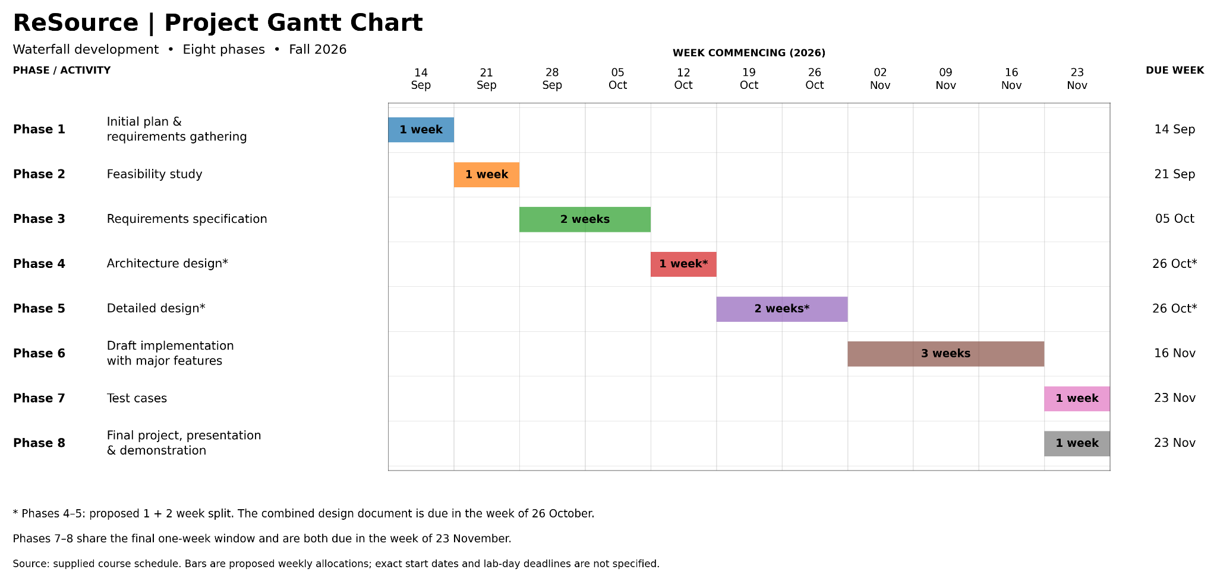

Recommendations
1. Build a minimum viable baseline first. Implement stable non-AI workflows before adding advanced intelligence. This reduces schedule and integration risk.
2. Keep humans in consequential decisions. Use AI to recommend, rank, or explain; require authorized users to approve high-impact transfer, disposal, or allocation decisions. This aligns with the accountability and human-oversight orientation of the AI RMF [4].
3. Make AI behavior observable. Store recommendation inputs, scores/confidence where applicable, explanations, user decisions, and model/service version so results can be reviewed and tested [4], [5].
4. Treat the LLM assistant as a separate security boundary. Limit its tools and accessible data, validate outputs, and design specifically for prompt injection and sensitive-information disclosure risks [6].
5. Use security controls from the start. Design role-based access, authentication, logging, configuration management, incident handling, and least privilege into the prototype rather than adding them only at the end [7], [8].
6. Control scope explicitly. Classify features as essential, desirable, or future work and protect essential end-to-end functionality if schedule pressure increases [2], [3].
7. Document uncertainty. For AI and sustainability estimates, state assumptions, data limitations, and uncertainty instead of presenting estimated values as guaranteed facts [4], [5].

